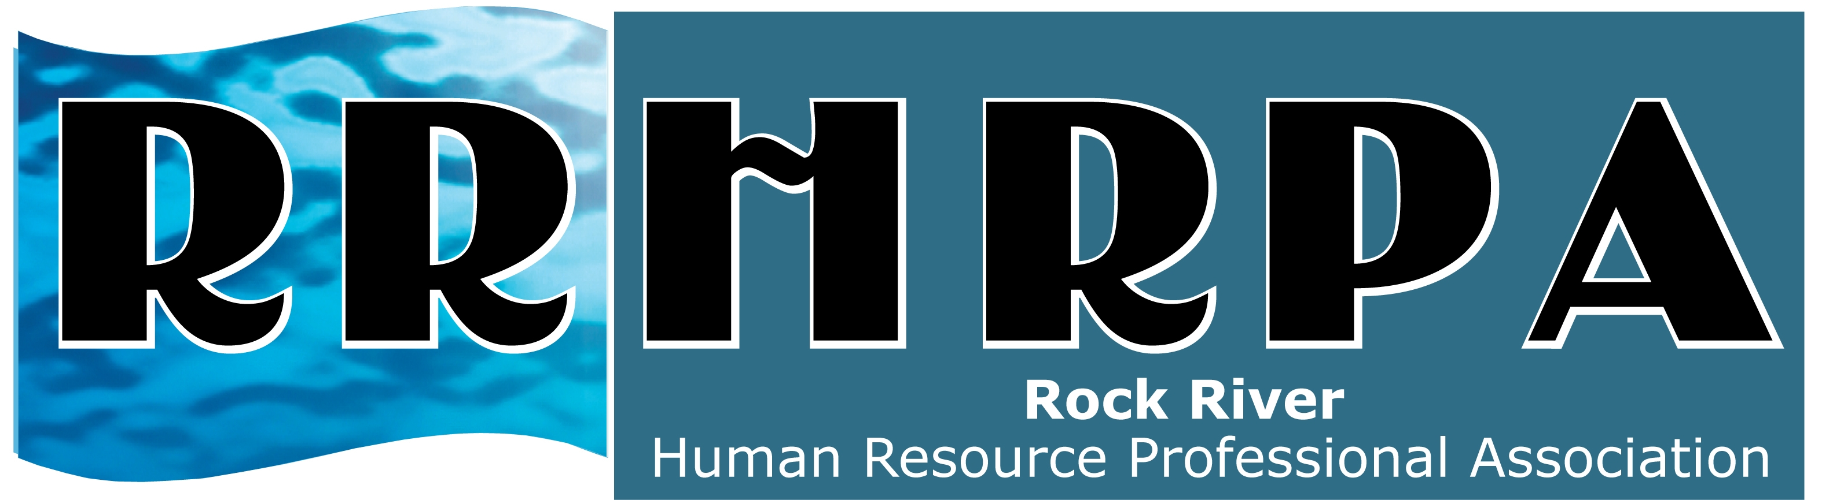
RRHRPA Annual ½ Day Seminar
July 26th – Sauk Valley Community College

Moving from Motivation to Inspiration:
The power of leadership influence!
Speaker: Lee Ann Piano
Attitude Expert

Lee Ann Piano has 25 years of success in sales, sales management, and professional training and has delivered over 500 seminars nationally and internationally. Her presentations are fun, fast-paced, content rich, and transform mediocre mind-sets into powerful positivity!

She enthusiastically shares the tools, techniques, concepts, and ideas that make managers more effective and inspiring leaders!

See our website for registration form: www.rrhrpa.shrm.org

